

Anti-accident systems for trucks
In spring 2008 the Ministry of Transport, Connekt/ITS Netherlands, TNO and Buck Consultants International started a large pilot to test five individual systems for preventing accidents with trucks.
The aim of the pilot is to improve safety and to maintain traffic flow. The five systems that are being incorporated into 3,000 vehicles will be extensively tested over a period of eight months.

Accidents involving trucks are responsible for 2-3 % of traffic jams caused by incidental factors (accidents, road works, events and the weather). Recent polls amongst the public suggest that the average road user believes that trucks are involved in around 44% of the ‘accident-based’ jams. It is a perception that is probably attributable to the considerable media attention given to truck accidents and the fact that accidents of this nature generate longer traffic jams.

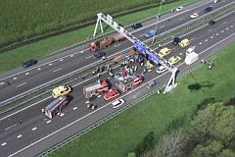

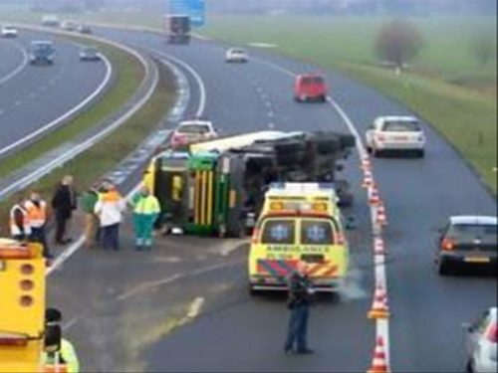

Large-scale test
A preliminary TNO study in May 2007 established that a large-scale test using anti-accident systems can help alleviate congestion and boost safety on the road. Although truck-safety systems are available commercially, not many systems are used. This is partly due to the high costs and partly to the relatively low cost-benefits gain for the transporter. However, society stands to gain much more from these systems through the reduction in accidents and congestion, something that could have a positive impact on the image of this key economic sector. These are good reasons for getting testing underway.
The proposed test concerns 3,000 vehicles from the entire truck fleet. This enables the impact of the pilot to be measured and an extensive registration of vehicle movements enables key information to be acquired on the operation of the various anti-accident systems. Two systems focus on the prevention of rear-end collisions and three on the prevention of tilting and side collisions. The vehicle movements of the trucks used in the pilot will be registered and processed over the eight-month period.

Main objectives
The pilot involves 3,000 trucks, mainly on Dutch roads. Besides this group, the project team will use test tracks to perform a number of tests which cannot be carried out on the public roads.

The test has three main objectives:
- To measure the impact of the large-scale implementation of anti-accident systems on traffic flow.
- To reduce the number of accidents involving trucks and to map out the impact on traffic safety.
- To gain insight into the effectiveness of the various systems which are able to contribute to truck safety.

Systems tested
- Lane Departure Warning Assist (LDWA) - retrofit
- Headway Monitoring and Warning and Forward Collision Warning (HMW + FCW) - retrofit
- Directional Control (DC)
- Adaptive Cruise Control (ACC)

And complementary parallel tests such as:
- Test track measuring with anti-tilting sensors
- Random tests with behavioural observations
- Monitoring of large fleets equipped with anti-accident systems and/or monitoring of specific target groups (tankers).

The Anti-accident systems for trucks project is one of the 40 short-term congestion approach projects initiated by the Ministry of Transport for the period 2006 to 2009, aimed at reducing congestions. For more information please contact Renate Leyten from FileProof at +31 88-7982 570 renate.leyten@rws.nl or Esther de Waard from Connekt at +31 15 251 6581 dewaard@connnekt.nl.




